**BVPIEEE INTRODUCTORY MEET 2014**

- Naman Sharma

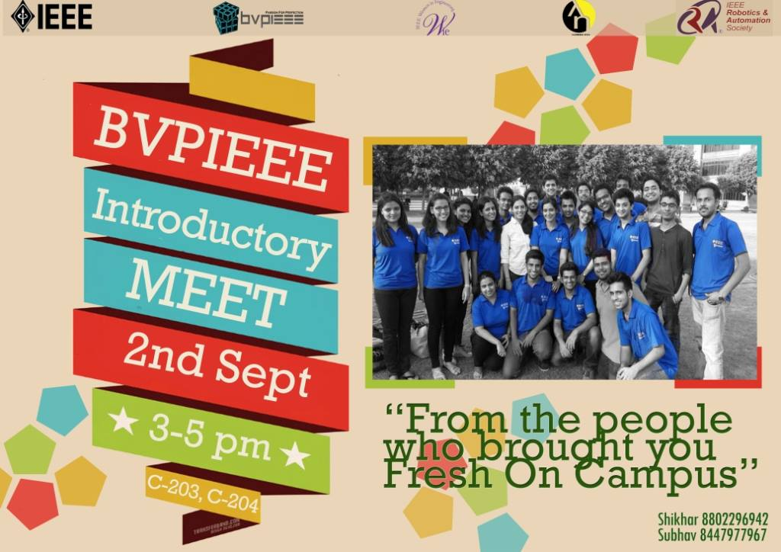  
  
The formal BVPIEEE Introductory Meet was organised on 2nd September 2014. The primary objectives of this meet were as follows:

1. To introduce IEEE and IEEE-HKN society from a broader perspective to freshers.

2. To share experiences, challenges and benefits of being a member.

3. To encourage them to join as a member of our student chapter.  
4. To make students aware of the various SIGs run under the banner of BVPIEEE.

The event witnessed a participation of over hundred students. The meet was initiated by student representatives with a presentation elucidating benefits of joining BVPIEEE followed by a video showing all the major events conducted in the previous session. WIE-BVPIEEE commenced the event by acquainting students with Women in Engineering (WIE) and giving a presentation about the activities undertaken by it like self-defence classes, STAR program etc. Subsequently, the various Special Interest groups such as **Drishti** (Photography club), **Robotix United**, **Codex** **BVCOE quiz club, Gamma (**Gaming, Multimedia and Animation SIG) and **E-Cell** gave presentations illustrating their purpose and motives. The students showed keen interest in the activities of these SIGs with Student Representatives having to stay back, overtime to answer all their questions.

Lambda Eta Chapter of IEEE-HKN also gave a presentation explaining the benefits of being associated with an honour society to students. Presentation also highlighted Outstanding Chapter award won by Lambda Eta Chapter, Arizona Student Leadership Conference 2013, R10 Conference held in Hyderabad, Cognizance (E-newsletter of Lambda Eta Chapter) and various campus activities like Student Mentorship Programme and Plantation drive.

One of BVPIEEE’s new initiatives, the technical chapter of RAS (Robotics and Automation Society), was also introduced and its benefits and mission discussed in length along with an interactive demonstration.

The event served its purpose of introducing IEEE, the world’s largest professional organization, and its student branch of BVCOE, to the audience and highlighting the diverse membership benefits.